1 run......

training 1 epoch...

3.765608310699463 seconds used......

1 training finished! average train loss: 2.5933970423305737

total clf loss: 21.650736093521118 total adv loss: 11.218506813049316

evaluating...

Confusion matrix, without normalization

[[ 11 27 3]

[ 8 82 5]

[187 381 146]]

Normalized confusion matrix

[[0.26829268 0.65853659 0.07317073]

[0.08421053 0.86315789 0.05263158]

[0.26190476 0.53361345 0.20448179]]

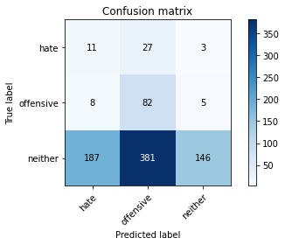

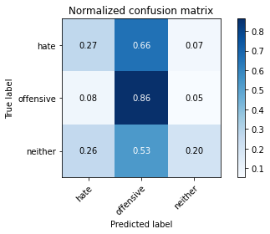

precision recall f1-score support

hate 0.05 0.27 0.09 41

offensive 0.17 0.86 0.28 95

neither 0.95 0.20 0.34 714

accuracy 0.28 850

macro avg 0.39 0.45 0.24 850

weighted avg 0.82 0.28 0.32 850

average eval_loss: 1.1574981767077779, accuracy: 0.2811764705882353

training 2 epoch...

3.753936767578125 seconds used......

2 training finished! average train loss: 2.2989325102637794

total clf loss: 18.43707311153412 total adv loss: 10.322389721870422

evaluating...

Confusion matrix, without normalization

[[ 31 9 1]

[ 35 49 11]

[314 104 296]]

Normalized confusion matrix

[[0.75609756 0.2195122 0.02439024]

[0.36842105 0.51578947 0.11578947]

[0.43977591 0.14565826 0.41456583]]

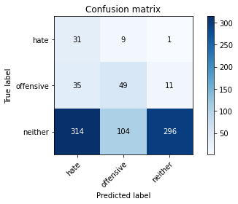

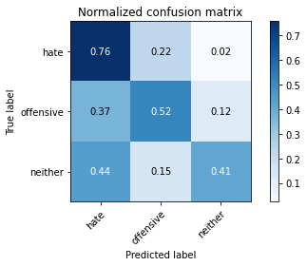

precision recall f1-score support

hate 0.08 0.76 0.15 41

offensive 0.30 0.52 0.38 95

neither 0.96 0.41 0.58 714

accuracy 0.44 850

macro avg 0.45 0.56 0.37 850

weighted avg 0.85 0.44 0.54 850

average eval_loss: 1.0806789592254993, accuracy: 0.4423529411764706

training 3 epoch...

3.790675640106201 seconds used......

3 training finished! average train loss: 2.159623475635753

total clf loss: 17.386519730091095 total adv loss: 9.663539737462997

evaluating...

Confusion matrix, without normalization

[[ 14 26 1]

[ 10 79 6]

[168 292 254]]

Normalized confusion matrix

[[0.34146341 0.63414634 0.02439024]

[0.10526316 0.83157895 0.06315789]

[0.23529412 0.40896359 0.3557423 ]]

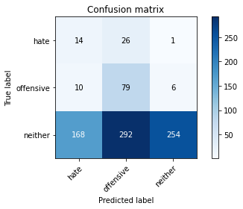

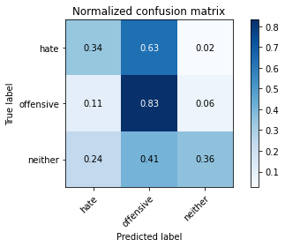

precision recall f1-score support

hate 0.07 0.34 0.12 41

offensive 0.20 0.83 0.32 95

neither 0.97 0.36 0.52 714

accuracy 0.41 850

macro avg 0.42 0.51 0.32 850

weighted avg 0.84 0.41 0.48 850

average eval_loss: 1.0719525425933127, accuracy: 0.4082352941176471

training 4 epoch...

3.7444329261779785 seconds used......

4 training finished! average train loss: 1.8913334397708668

total clf loss: 15.90600860118866 total adv loss: 8.123329848051071

evaluating...

Confusion matrix, without normalization

[[ 28 12 1]

[ 32 60 3]

[321 165 228]]

Normalized confusion matrix

[[0.68292683 0.29268293 0.02439024]

[0.33684211 0.63157895 0.03157895]

[0.44957983 0.23109244 0.31932773]]

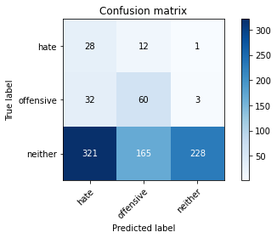

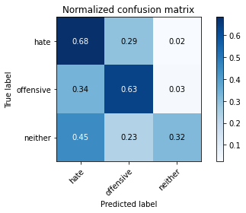

precision recall f1-score support

hate 0.07 0.68 0.13 41

offensive 0.25 0.63 0.36 95

neither 0.98 0.32 0.48 714

accuracy 0.37 850

macro avg 0.44 0.54 0.33 850

weighted avg 0.86 0.37 0.45 850

average eval_loss: 1.106614209884821, accuracy: 0.37176470588235294

training 5 epoch...

3.735818386077881 seconds used......

5 training finished! average train loss: 1.4225660983253927

total clf loss: 13.608352541923523 total adv loss: 5.287635415792465

evaluating...

Confusion matrix, without normalization

[[ 30 9 2]

[ 19 68 8]

[252 146 316]]

Normalized confusion matrix

[[0.73170732 0.2195122 0.04878049]

[0.2 0.71578947 0.08421053]

[0.35294118 0.20448179 0.44257703]]

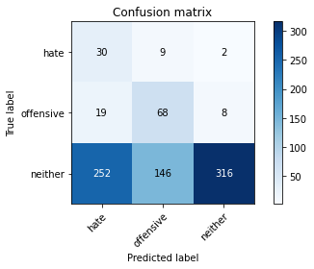

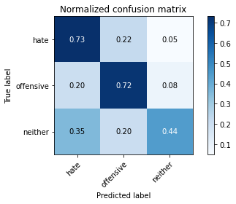

precision recall f1-score support

hate 0.10 0.73 0.18 41

offensive 0.30 0.72 0.43 95

neither 0.97 0.44 0.61 714

accuracy 0.49 850

macro avg 0.46 0.63 0.40 850

weighted avg 0.85 0.49 0.57 850

average eval_loss: 0.999378732470579, accuracy: 0.48705882352941177

training 6 epoch...

3.80068039894104 seconds used......

6 training finished! average train loss: 1.0093026020947624

total clf loss: 11.007137298583984 total adv loss: 3.0755034908652306

evaluating...

Confusion matrix, without normalization

[[ 25 14 2]

[ 18 73 4]

[247 197 270]]

Normalized confusion matrix

[[0.6097561 0.34146341 0.04878049]

[0.18947368 0.76842105 0.04210526]

[0.34593838 0.27591036 0.37815126]]

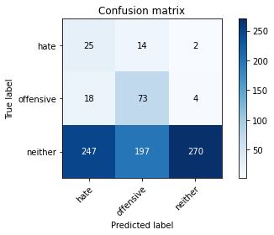

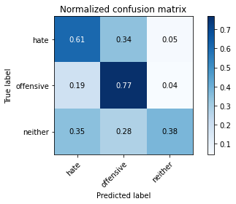

precision recall f1-score support

hate 0.09 0.61 0.15 41

offensive 0.26 0.77 0.39 95

neither 0.98 0.38 0.55 714

accuracy 0.43 850

macro avg 0.44 0.59 0.36 850

weighted avg 0.85 0.43 0.51 850

average eval_loss: 1.060246227092521, accuracy: 0.4329411764705882

training 7 epoch...

3.7508044242858887 seconds used......

7 training finished! average train loss: 0.7598941641695359

total clf loss: 8.734607994556427 total adv loss: 2.091796406544745

evaluating...

Confusion matrix, without normalization

[[ 31 8 2]

[ 30 60 5]

[296 162 256]]

Normalized confusion matrix

[[0.75609756 0.19512195 0.04878049]

[0.31578947 0.63157895 0.05263158]

[0.41456583 0.22689076 0.35854342]]

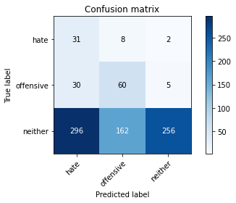

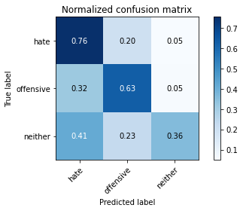

precision recall f1-score support

hate 0.09 0.76 0.16 41

offensive 0.26 0.63 0.37 95

neither 0.97 0.36 0.52 714

accuracy 0.41 850

macro avg 0.44 0.58 0.35 850

weighted avg 0.85 0.41 0.49 850

average eval_loss: 1.0970207369604776, accuracy: 0.4082352941176471

training 8 epoch...

3.7823476791381836 seconds used......

8 training finished! average train loss: 0.456031248849981

total clf loss: 6.867477983236313 total adv loss: 0.44252663804218173

evaluating...

Confusion matrix, without normalization

[[ 23 16 2]

[ 17 74 4]

[230 220 264]]

Normalized confusion matrix

[[0.56097561 0.3902439 0.04878049]

[0.17894737 0.77894737 0.04210526]

[0.32212885 0.30812325 0.3697479 ]]

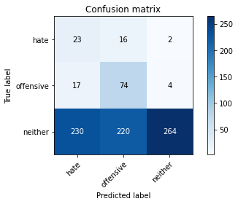

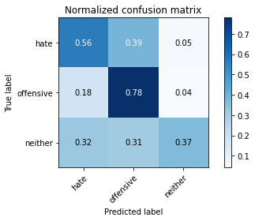

precision recall f1-score support

hate 0.09 0.56 0.15 41

offensive 0.24 0.78 0.37 95

neither 0.98 0.37 0.54 714

accuracy 0.42 850

macro avg 0.43 0.57 0.35 850

weighted avg 0.85 0.42 0.50 850

average eval_loss: 1.1394441855508228, accuracy: 0.42470588235294116

training 9 epoch...

3.763336181640625 seconds used......

9 training finished! average train loss: 0.3079197292818743

total clf loss: 5.011785328388214 total adv loss: 0.11142504424788058

evaluating...

Confusion matrix, without normalization

[[ 21 17 3]

[ 15 73 7]

[184 204 326]]

Normalized confusion matrix

[[0.51219512 0.41463415 0.07317073]

[0.15789474 0.76842105 0.07368421]

[0.25770308 0.28571429 0.45658263]]

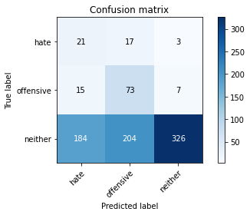

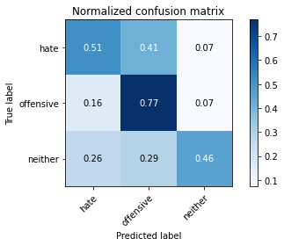

precision recall f1-score support

hate 0.10 0.51 0.16 41

offensive 0.25 0.77 0.38 95

neither 0.97 0.46 0.62 714

accuracy 0.49 850

macro avg 0.44 0.58 0.39 850

weighted avg 0.85 0.49 0.57 850

average eval_loss: 1.0579254349996878, accuracy: 0.49411764705882355

training 10 epoch...

3.73431134223938 seconds used......

10 training finished! average train loss: 0.23476698819328756

total clf loss: 3.903891608119011 total adv loss: 0.04357361246366054

evaluating...

Confusion matrix, without normalization

[[ 28 5 8]

[ 28 36 31]

[205 99 410]]

Normalized confusion matrix

[[0.68292683 0.12195122 0.19512195]

[0.29473684 0.37894737 0.32631579]

[0.28711485 0.13865546 0.57422969]]

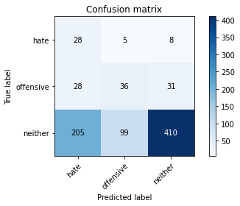

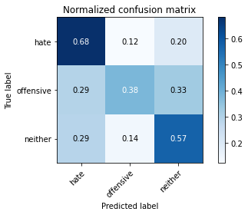

precision recall f1-score support

hate 0.11 0.68 0.19 41

offensive 0.26 0.38 0.31 95

neither 0.91 0.57 0.71 714

accuracy 0.56 850

macro avg 0.43 0.55 0.40 850

weighted avg 0.80 0.56 0.64 850

average eval_loss: 0.9452202063660289, accuracy: 0.5576470588235294

2 run......

training 1 epoch...

3.762417793273926 seconds used......

1 training finished! average train loss: 2.5575226755703198

total clf loss: 21.422582626342773 total adv loss: 11.027651131153107

evaluating...

Confusion matrix, without normalization

[[ 31 8 2]

[ 63 4 28]

[335 69 310]]

Normalized confusion matrix

[[0.75609756 0.19512195 0.04878049]

[0.66315789 0.04210526 0.29473684]

[0.46918768 0.09663866 0.43417367]]

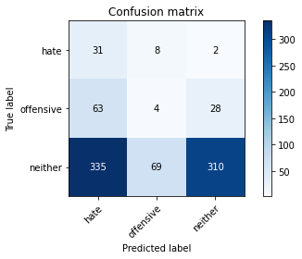

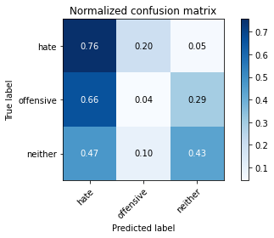

precision recall f1-score support

hate 0.07 0.76 0.13 41

offensive 0.05 0.04 0.05 95

neither 0.91 0.43 0.59 714

accuracy 0.41 850

macro avg 0.34 0.41 0.26 850

weighted avg 0.77 0.41 0.51 850

average eval_loss: 1.1166913356891899, accuracy: 0.40588235294117647

training 2 epoch...

3.757819652557373 seconds used......

2 training finished! average train loss: 2.3418859173269833

total clf loss: 18.47087252140045 total adv loss: 10.670593917369843

evaluating...

Confusion matrix, without normalization

[[ 18 22 1]

[ 15 69 11]

[125 348 241]]

Normalized confusion matrix

[[0.43902439 0.53658537 0.02439024]

[0.15789474 0.72631579 0.11578947]

[0.17507003 0.48739496 0.33753501]]

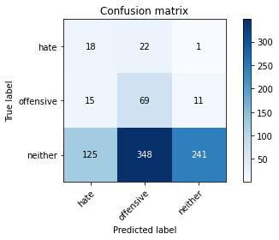

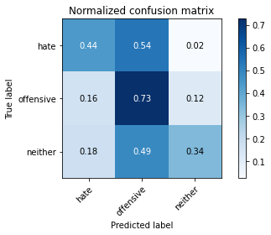

precision recall f1-score support

hate 0.11 0.44 0.18 41

offensive 0.16 0.73 0.26 95

neither 0.95 0.34 0.50 714

accuracy 0.39 850

macro avg 0.41 0.50 0.31 850

weighted avg 0.82 0.39 0.46 850

average eval_loss: 1.1134124218031418, accuracy: 0.38588235294117645

training 3 epoch...

3.7733075618743896 seconds used......

3 training finished! average train loss: 2.1871024580562817

total clf loss: 17.484908938407898 total adv loss: 9.84791648387909

evaluating...

Confusion matrix, without normalization

[[ 24 14 3]

[ 26 55 14]

[200 205 309]]

Normalized confusion matrix

[[0.58536585 0.34146341 0.07317073]

[0.27368421 0.57894737 0.14736842]

[0.28011204 0.28711485 0.43277311]]

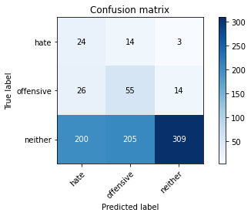

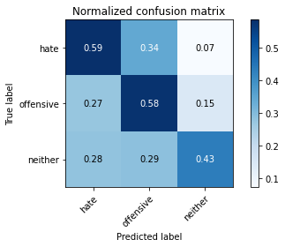

precision recall f1-score support

hate 0.10 0.59 0.16 41

offensive 0.20 0.58 0.30 95

neither 0.95 0.43 0.59 714

accuracy 0.46 850

macro avg 0.41 0.53 0.35 850

weighted avg 0.82 0.46 0.54 850

average eval_loss: 1.073238347851953, accuracy: 0.45647058823529413

training 4 epoch...

3.739438533782959 seconds used......

4 training finished! average train loss: 1.9297534087124992

total clf loss: 16.004841804504395 total adv loss: 8.40048299729824

evaluating...

Confusion matrix, without normalization

[[ 32 8 1]

[ 44 45 6]

[339 145 230]]

Normalized confusion matrix

[[0.7804878 0.19512195 0.02439024]

[0.46315789 0.47368421 0.06315789]

[0.47478992 0.20308123 0.32212885]]

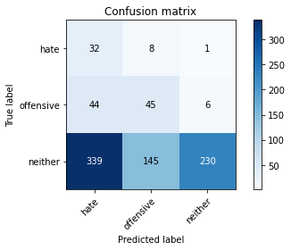

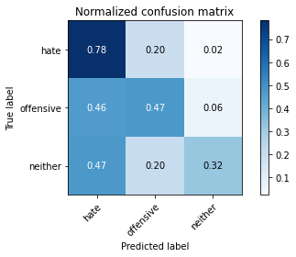

precision recall f1-score support

hate 0.08 0.78 0.14 41

offensive 0.23 0.47 0.31 95

neither 0.97 0.32 0.48 714

accuracy 0.36 850

macro avg 0.42 0.53 0.31 850

weighted avg 0.84 0.36 0.45 850

average eval_loss: 1.1533949610798857, accuracy: 0.3611764705882353

training 5 epoch...

3.7857866287231445 seconds used......

5 training finished! average train loss: 1.4911720717654509

total clf loss: 13.75089019536972 total adv loss: 5.799517460167408

evaluating...

Confusion matrix, without normalization

[[ 23 14 4]

[ 18 60 17]

[170 162 382]]

Normalized confusion matrix

[[0.56097561 0.34146341 0.09756098]

[0.18947368 0.63157895 0.17894737]

[0.23809524 0.22689076 0.53501401]]

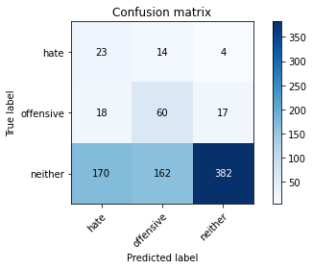

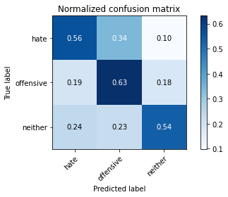

precision recall f1-score support

hate 0.11 0.56 0.18 41

offensive 0.25 0.63 0.36 95

neither 0.95 0.54 0.68 714

accuracy 0.55 850

macro avg 0.44 0.58 0.41 850

weighted avg 0.83 0.55 0.62 850

average eval_loss: 0.9752703627874685, accuracy: 0.5470588235294118

training 6 epoch...

3.7745234966278076 seconds used......

6 training finished! average train loss: 0.9306302561479456

total clf loss: 10.710712790489197 total adv loss: 2.5550008043646812

evaluating...

Confusion matrix, without normalization

[[ 24 10 7]

[ 17 59 19]

[147 122 445]]

Normalized confusion matrix

[[0.58536585 0.24390244 0.17073171]

[0.17894737 0.62105263 0.2 ]

[0.20588235 0.17086835 0.6232493 ]]

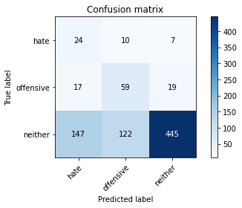

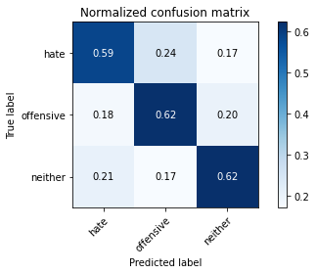

precision recall f1-score support

hate 0.13 0.59 0.21 41

offensive 0.31 0.62 0.41 95

neither 0.94 0.62 0.75 714

accuracy 0.62 850

macro avg 0.46 0.61 0.46 850

weighted avg 0.83 0.62 0.69 850

average eval_loss: 0.8774247419002444, accuracy: 0.6211764705882353

training 7 epoch...

3.7470381259918213 seconds used......

7 training finished! average train loss: 0.5521923864589018

total clf loss: 7.724223583936691 total adv loss: 0.8315235152840614

evaluating...

Confusion matrix, without normalization

[[ 29 9 3]

[ 23 59 13]

[198 175 341]]

Normalized confusion matrix

[[0.70731707 0.2195122 0.07317073]

[0.24210526 0.62105263 0.13684211]

[0.27731092 0.24509804 0.47759104]]

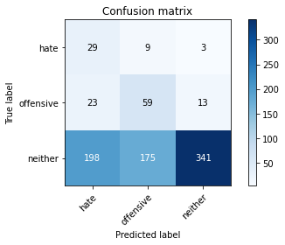

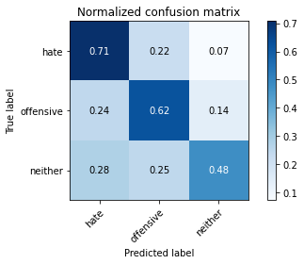

precision recall f1-score support

hate 0.12 0.71 0.20 41

offensive 0.24 0.62 0.35 95

neither 0.96 0.48 0.64 714

accuracy 0.50 850

macro avg 0.44 0.60 0.40 850

weighted avg 0.84 0.50 0.58 850

average eval_loss: 1.0318295366542285, accuracy: 0.5047058823529412

training 8 epoch...

3.738271713256836 seconds used......

8 training finished! average train loss: 0.3173738183344112

total clf loss: 5.144387915730476 total adv loss: 0.12548350647557527

evaluating...

Confusion matrix, without normalization

[[ 21 11 9]

[ 14 65 16]

[146 185 383]]

Normalized confusion matrix

[[0.51219512 0.26829268 0.2195122 ]

[0.14736842 0.68421053 0.16842105]

[0.20448179 0.25910364 0.53641457]]

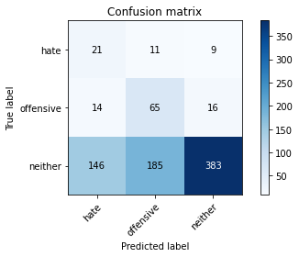

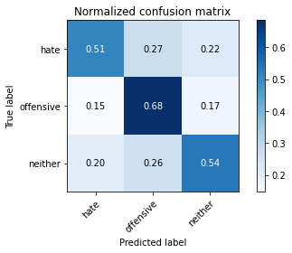

precision recall f1-score support

hate 0.12 0.51 0.19 41

offensive 0.25 0.68 0.37 95

neither 0.94 0.54 0.68 714

accuracy 0.55 850

macro avg 0.43 0.58 0.41 850

weighted avg 0.82 0.55 0.62 850

average eval_loss: 0.9737922576970832, accuracy: 0.5517647058823529

training 9 epoch...

3.8077001571655273 seconds used......

9 training finished! average train loss: 0.23183122978490942

total clf loss: 3.532087817788124 total adv loss: 0.20452151108474936

evaluating...

Confusion matrix, without normalization

[[ 22 10 9]

[ 22 49 24]

[170 122 422]]

Normalized confusion matrix

[[0.53658537 0.24390244 0.2195122 ]

[0.23157895 0.51578947 0.25263158]

[0.23809524 0.17086835 0.59103641]]

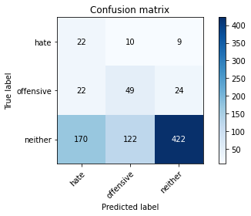

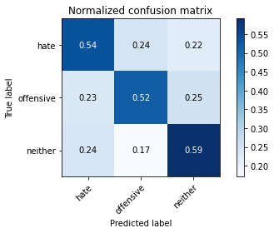

precision recall f1-score support

hate 0.10 0.54 0.17 41

offensive 0.27 0.52 0.36 95

neither 0.93 0.59 0.72 714

accuracy 0.58 850

macro avg 0.43 0.55 0.42 850

weighted avg 0.81 0.58 0.65 850

average eval_loss: 0.9438768396543902, accuracy: 0.58

training 10 epoch...

3.7390732765197754 seconds used......

10 training finished! average train loss: 0.2145274347242187

total clf loss: 2.8238032460212708 total adv loss: 0.4115815642871894

evaluating...

Confusion matrix, without normalization

[[ 28 8 5]

[ 31 49 15]

[230 134 350]]

Normalized confusion matrix

[[0.68292683 0.19512195 0.12195122]

[0.32631579 0.51578947 0.15789474]

[0.32212885 0.18767507 0.49019608]]

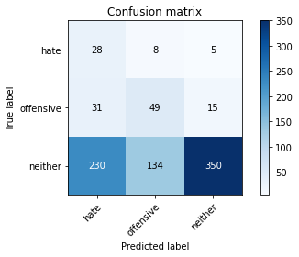

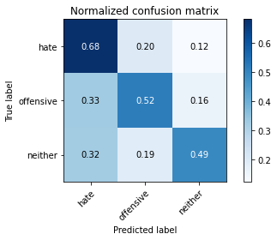

precision recall f1-score support

hate 0.10 0.68 0.17 41

offensive 0.26 0.52 0.34 95

neither 0.95 0.49 0.65 714

accuracy 0.50 850

macro avg 0.43 0.56 0.39 850

weighted avg 0.83 0.50 0.59 850

average eval_loss: 1.1412205453528914, accuracy: 0.5023529411764706

3 run......

training 1 epoch...

3.7650277614593506 seconds used......

1 training finished! average train loss: 2.6486437180463005

total clf loss: 22.351497173309326 total adv loss: 11.337722837924957

evaluating...

Confusion matrix, without normalization

[[ 23 11 7]

[ 13 77 5]

[215 292 207]]

Normalized confusion matrix

[[0.56097561 0.26829268 0.17073171]

[0.13684211 0.81052632 0.05263158]

[0.30112045 0.40896359 0.28991597]]

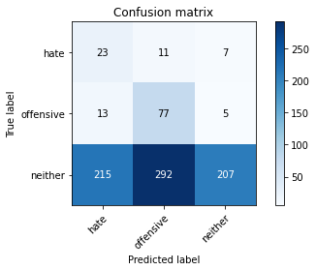

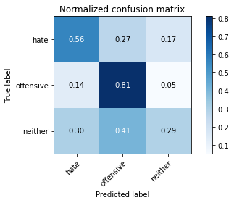

precision recall f1-score support

hate 0.09 0.56 0.16 41

offensive 0.20 0.81 0.32 95

neither 0.95 0.29 0.44 714

accuracy 0.36 850

macro avg 0.41 0.55 0.31 850

weighted avg 0.82 0.36 0.42 850

average eval_loss: 1.1432878957238308, accuracy: 0.3611764705882353

training 2 epoch...

3.7427570819854736 seconds used......

2 training finished! average train loss: 2.304543705547557

total clf loss: 18.265979051589966 total adv loss: 10.455631822347641

evaluating...

Confusion matrix, without normalization

[[ 39 0 2]

[ 54 30 11]

[394 31 289]]

Normalized confusion matrix

[[0.95121951 0. 0.04878049]

[0.56842105 0.31578947 0.11578947]

[0.55182073 0.04341737 0.4047619 ]]

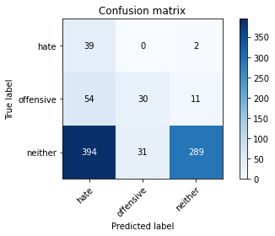

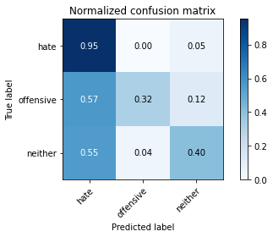

precision recall f1-score support

hate 0.08 0.95 0.15 41

offensive 0.49 0.32 0.38 95

neither 0.96 0.40 0.57 714

accuracy 0.42 850

macro avg 0.51 0.56 0.37 850

weighted avg 0.86 0.42 0.53 850

average eval_loss: 1.0643927718317785, accuracy: 0.4211764705882353

training 3 epoch...

3.8497252464294434 seconds used......

3 training finished! average train loss: 2.0525921723421883

total clf loss: 16.985840141773224 total adv loss: 8.954113334417343

evaluating...

Confusion matrix, without normalization

[[ 28 11 2]

[ 22 68 5]

[236 196 282]]

Normalized confusion matrix

[[0.68292683 0.26829268 0.04878049]

[0.23157895 0.71578947 0.05263158]

[0.33053221 0.2745098 0.39495798]]

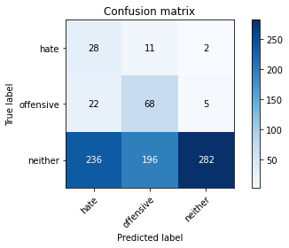

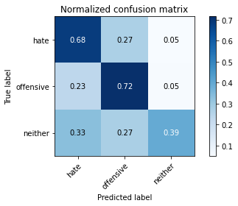

precision recall f1-score support

hate 0.10 0.68 0.17 41

offensive 0.25 0.72 0.37 95

neither 0.98 0.39 0.56 714

accuracy 0.44 850

macro avg 0.44 0.60 0.37 850

weighted avg 0.85 0.44 0.52 850

average eval_loss: 1.0421664340551509, accuracy: 0.4447058823529412

training 4 epoch...

3.7369489669799805 seconds used......

4 training finished! average train loss: 1.701828451717601

total clf loss: 15.07580304145813 total adv loss: 6.927640222012997

evaluating...

Confusion matrix, without normalization

[[ 38 1 2]

[ 50 35 10]

[376 61 277]]

Normalized confusion matrix

[[0.92682927 0.02439024 0.04878049]

[0.52631579 0.36842105 0.10526316]

[0.52661064 0.08543417 0.38795518]]

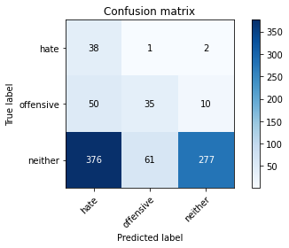

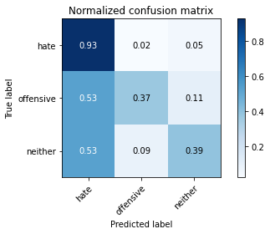

precision recall f1-score support

hate 0.08 0.93 0.15 41

offensive 0.36 0.37 0.36 95

neither 0.96 0.39 0.55 714

accuracy 0.41 850

macro avg 0.47 0.56 0.36 850

weighted avg 0.85 0.41 0.51 850

average eval_loss: 1.0557203181954318, accuracy: 0.4117647058823529

training 5 epoch...

3.7338147163391113 seconds used......

5 training finished! average train loss: 1.4996187967412613

total clf loss: 12.873765528202057 total adv loss: 6.309877172112465

evaluating...

Confusion matrix, without normalization

[[ 14 21 6]

[ 7 81 7]

[ 96 330 288]]

Normalized confusion matrix

[[0.34146341 0.51219512 0.14634146]

[0.07368421 0.85263158 0.07368421]

[0.13445378 0.46218487 0.40336134]]

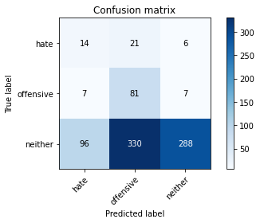

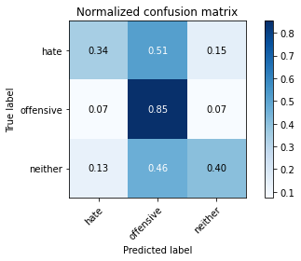

precision recall f1-score support

hate 0.12 0.34 0.18 41

offensive 0.19 0.85 0.31 95

neither 0.96 0.40 0.57 714

accuracy 0.45 850

macro avg 0.42 0.53 0.35 850

weighted avg 0.83 0.45 0.52 850

average eval_loss: 0.9749604713085086, accuracy: 0.4505882352941176

training 6 epoch...

3.7778353691101074 seconds used......

6 training finished! average train loss: 1.006071174845976

total clf loss: 10.9626345038414 total adv loss: 3.070287674665451

evaluating...

Confusion matrix, without normalization

[[ 31 8 2]

[ 36 48 11]

[279 129 306]]

Normalized confusion matrix

[[0.75609756 0.19512195 0.04878049]

[0.37894737 0.50526316 0.11578947]

[0.3907563 0.18067227 0.42857143]]

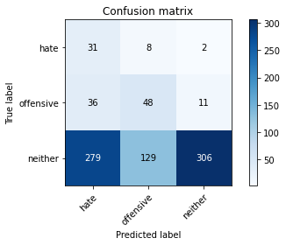

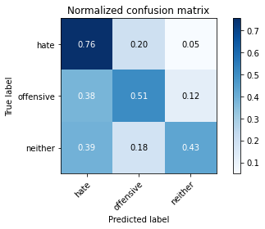

precision recall f1-score support

hate 0.09 0.76 0.16 41

offensive 0.26 0.51 0.34 95

neither 0.96 0.43 0.59 714

accuracy 0.45 850

macro avg 0.44 0.56 0.37 850

weighted avg 0.84 0.45 0.54 850

average eval_loss: 1.0253870667413223, accuracy: 0.45294117647058824

training 7 epoch...

3.737312078475952 seconds used......

7 training finished! average train loss: 0.5740521252155304

total clf loss: 7.740257054567337 total adv loss: 1.0093145295977592

evaluating...

Confusion matrix, without normalization

[[ 23 11 7]

[ 14 67 14]

[164 246 304]]

Normalized confusion matrix

[[0.56097561 0.26829268 0.17073171]

[0.14736842 0.70526316 0.14736842]

[0.22969188 0.34453782 0.42577031]]

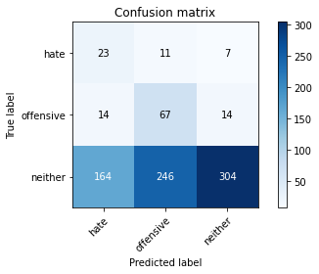

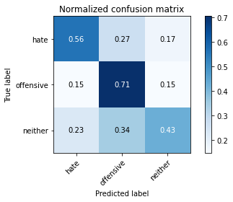

precision recall f1-score support

hate 0.11 0.56 0.19 41

offensive 0.21 0.71 0.32 95

neither 0.94 0.43 0.59 714

accuracy 0.46 850

macro avg 0.42 0.56 0.37 850

weighted avg 0.81 0.46 0.54 850

average eval_loss: 0.9939643158469089, accuracy: 0.46352941176470586

training 8 epoch...

3.7384910583496094 seconds used......

8 training finished! average train loss: 0.390274563256432

total clf loss: 5.9350612461566925 total adv loss: 0.34980316436849535

evaluating...

Confusion matrix, without normalization

[[ 18 6 17]

[ 9 57 29]

[106 133 475]]

Normalized confusion matrix

[[0.43902439 0.14634146 0.41463415]

[0.09473684 0.6 0.30526316]

[0.14845938 0.18627451 0.66526611]]

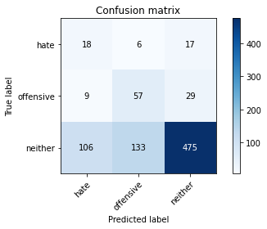

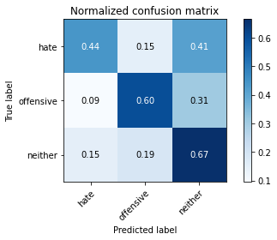

precision recall f1-score support

hate 0.14 0.44 0.21 41

offensive 0.29 0.60 0.39 95

neither 0.91 0.67 0.77 714

accuracy 0.65 850

macro avg 0.45 0.57 0.46 850

weighted avg 0.80 0.65 0.70 850

average eval_loss: 0.7839655671701875, accuracy: 0.6470588235294118

training 9 epoch...

3.763402223587036 seconds used......

9 training finished! average train loss: 0.26233425999388976

total clf loss: 4.240322127938271 total adv loss: 0.10968014469835907

evaluating...

Confusion matrix, without normalization

[[ 21 6 14]

[ 15 49 31]

[151 116 447]]

Normalized confusion matrix

[[0.51219512 0.14634146 0.34146341]

[0.15789474 0.51578947 0.32631579]

[0.21148459 0.16246499 0.62605042]]

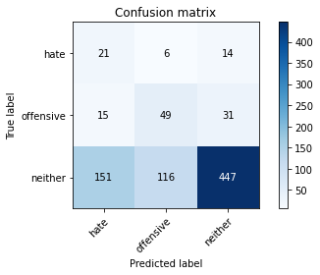

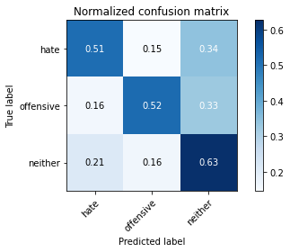

precision recall f1-score support

hate 0.11 0.51 0.18 41

offensive 0.29 0.52 0.37 95

neither 0.91 0.63 0.74 714

accuracy 0.61 850

macro avg 0.44 0.55 0.43 850

weighted avg 0.80 0.61 0.67 850

average eval_loss: 0.864552878363188, accuracy: 0.6082352941176471

training 10 epoch...

3.7388460636138916 seconds used......

10 training finished! average train loss: 0.17650401899043253

total clf loss: 2.9571932181715965 total adv loss: 0.021687564032617956

evaluating...

Confusion matrix, without normalization

[[ 23 9 9]

[ 22 52 21]

[182 148 384]]

Normalized confusion matrix

[[0.56097561 0.2195122 0.2195122 ]

[0.23157895 0.54736842 0.22105263]

[0.25490196 0.20728291 0.53781513]]

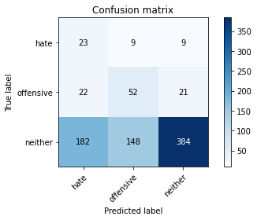

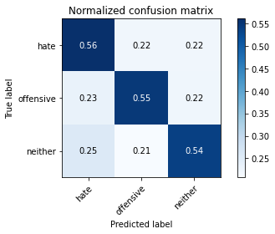

precision recall f1-score support

hate 0.10 0.56 0.17 41

offensive 0.25 0.55 0.34 95

neither 0.93 0.54 0.68 714

accuracy 0.54 850

macro avg 0.43 0.55 0.40 850

weighted avg 0.81 0.54 0.62 850

average eval_loss: 1.0040545179400333, accuracy: 0.54

4 run......

training 1 epoch...

3.750335454940796 seconds used......

1 training finished! average train loss: 2.5633976179010727

total clf loss: 21.416544437408447 total adv loss: 11.080607652664185

evaluating...

Confusion matrix, without normalization

[[ 32 5 4]

[ 70 4 21]

[436 55 223]]

Normalized confusion matrix

[[0.7804878 0.12195122 0.09756098]

[0.73684211 0.04210526 0.22105263]

[0.61064426 0.07703081 0.31232493]]

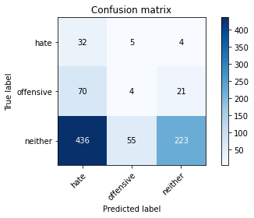

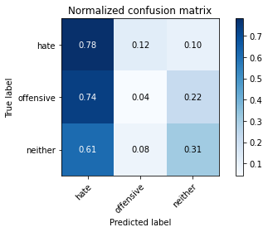

precision recall f1-score support

hate 0.06 0.78 0.11 41

offensive 0.06 0.04 0.05 95

neither 0.90 0.31 0.46 714

accuracy 0.30 850

macro avg 0.34 0.38 0.21 850

weighted avg 0.77 0.30 0.40 850

average eval_loss: 1.151087030421856, accuracy: 0.30470588235294116

training 2 epoch...

3.770777940750122 seconds used......

2 training finished! average train loss: 2.301417855655446

total clf loss: 18.37962532043457 total adv loss: 10.372238993644714

evaluating...

Confusion matrix, without normalization

[[ 12 27 2]

[ 2 79 14]

[102 373 239]]

Normalized confusion matrix

[[0.29268293 0.65853659 0.04878049]

[0.02105263 0.83157895 0.14736842]

[0.14285714 0.52240896 0.33473389]]

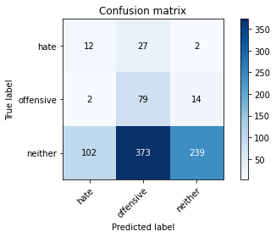

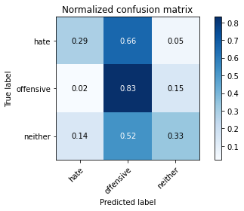

precision recall f1-score support

hate 0.10 0.29 0.15 41

offensive 0.16 0.83 0.28 95

neither 0.94 0.33 0.49 714

accuracy 0.39 850

macro avg 0.40 0.49 0.31 850

weighted avg 0.81 0.39 0.45 850

average eval_loss: 1.1085202000861945, accuracy: 0.38823529411764707

training 3 epoch...

3.754591941833496 seconds used......

3 training finished! average train loss: 2.188393101972692

total clf loss: 17.25063908100128 total adv loss: 9.976022094488144

evaluating...

Confusion matrix, without normalization

[[ 35 5 1]

[ 42 44 9]

[363 120 231]]

Normalized confusion matrix

[[0.85365854 0.12195122 0.02439024]

[0.44210526 0.46315789 0.09473684]

[0.50840336 0.16806723 0.32352941]]

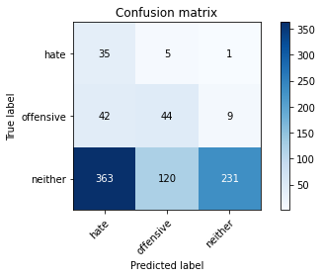

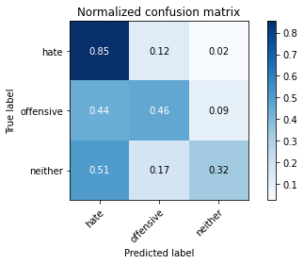

precision recall f1-score support

hate 0.08 0.85 0.15 41

offensive 0.26 0.46 0.33 95

neither 0.96 0.32 0.48 714

accuracy 0.36 850

macro avg 0.43 0.55 0.32 850

weighted avg 0.84 0.36 0.45 850

average eval_loss: 1.1211819149727045, accuracy: 0.36470588235294116

training 4 epoch...

3.7221577167510986 seconds used......

4 training finished! average train loss: 1.976858279284309

total clf loss: 16.068883299827576 total adv loss: 8.768853694200516

evaluating...

Confusion matrix, without normalization

[[ 30 8 3]

[ 25 52 18]

[257 144 313]]

Normalized confusion matrix

[[0.73170732 0.19512195 0.07317073]

[0.26315789 0.54736842 0.18947368]

[0.35994398 0.20168067 0.43837535]]

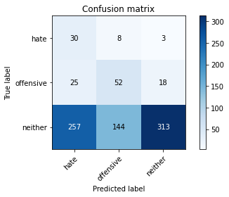

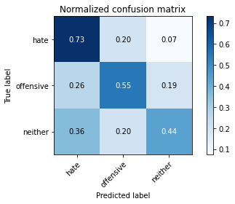

precision recall f1-score support

hate 0.10 0.73 0.17 41

offensive 0.25 0.55 0.35 95

neither 0.94 0.44 0.60 714

accuracy 0.46 850

macro avg 0.43 0.57 0.37 850

weighted avg 0.82 0.46 0.55 850

average eval_loss: 1.04301230851994, accuracy: 0.4647058823529412

training 5 epoch...

3.7200071811676025 seconds used......

5 training finished! average train loss: 1.5034663536969353

total clf loss: 13.95904541015625 total adv loss: 5.799941271543503

evaluating...

Confusion matrix, without normalization

[[ 28 10 3]

[ 17 64 14]

[207 169 338]]

Normalized confusion matrix

[[0.68292683 0.24390244 0.07317073]

[0.17894737 0.67368421 0.14736842]

[0.28991597 0.23669468 0.47338936]]

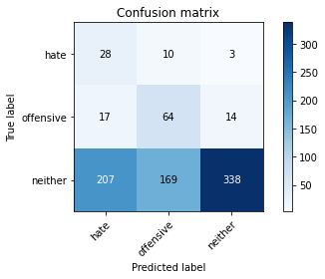

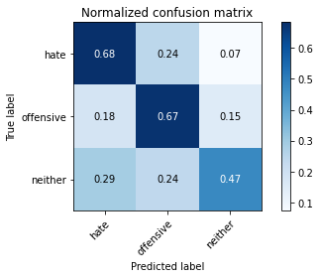

precision recall f1-score support

hate 0.11 0.68 0.19 41

offensive 0.26 0.67 0.38 95

neither 0.95 0.47 0.63 714

accuracy 0.51 850

macro avg 0.44 0.61 0.40 850

weighted avg 0.83 0.51 0.58 850

average eval_loss: 0.9888123786726664, accuracy: 0.5058823529411764

training 6 epoch...

3.8092000484466553 seconds used......

6 training finished! average train loss: 0.9413033162846285

total clf loss: 11.120803833007812 total adv loss: 2.440676361322403

evaluating...

Confusion matrix, without normalization

[[ 29 9 3]

[ 17 73 5]

[236 232 246]]

Normalized confusion matrix

[[0.70731707 0.2195122 0.07317073]

[0.17894737 0.76842105 0.05263158]

[0.33053221 0.32492997 0.34453782]]

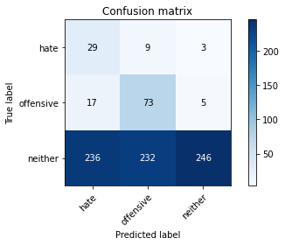

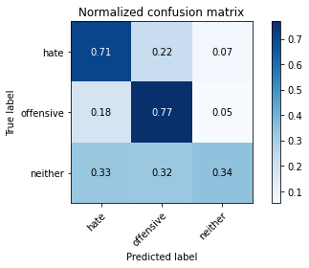

precision recall f1-score support

hate 0.10 0.71 0.18 41

offensive 0.23 0.77 0.36 95

neither 0.97 0.34 0.51 714

accuracy 0.41 850

macro avg 0.43 0.61 0.35 850

weighted avg 0.84 0.41 0.48 850

average eval_loss: 1.0956378357354986, accuracy: 0.40941176470588236

training 7 epoch...

3.743496894836426 seconds used......

7 training finished! average train loss: 0.5826577509150785

total clf loss: 8.39180901646614 total adv loss: 0.7566864192485809

evaluating...

Confusion matrix, without normalization

[[ 29 8 4]

[ 24 60 11]

[236 194 284]]

Normalized confusion matrix

[[0.70731707 0.19512195 0.09756098]

[0.25263158 0.63157895 0.11578947]

[0.33053221 0.27170868 0.3977591 ]]

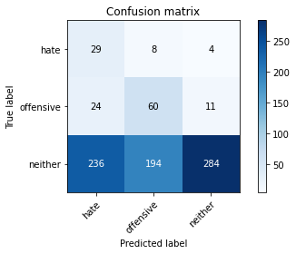

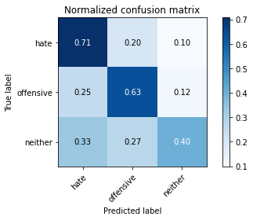

precision recall f1-score support

hate 0.10 0.71 0.18 41

offensive 0.23 0.63 0.34 95

neither 0.95 0.40 0.56 714

accuracy 0.44 850

macro avg 0.43 0.58 0.36 850

weighted avg 0.83 0.44 0.52 850

average eval_loss: 1.0832510126191517, accuracy: 0.4388235294117647

training 8 epoch...

3.727116584777832 seconds used......

8 training finished! average train loss: 0.3653453045031604

total clf loss: 6.110186949372292 total adv loss: 0.050341588677838445

evaluating...

Confusion matrix, without normalization

[[ 26 6 9]

[ 13 60 22]

[138 159 417]]

Normalized confusion matrix

[[0.63414634 0.14634146 0.2195122 ]

[0.13684211 0.63157895 0.23157895]

[0.19327731 0.22268908 0.58403361]]

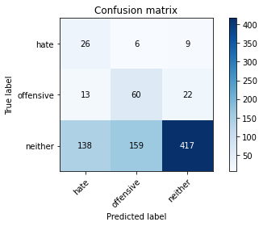

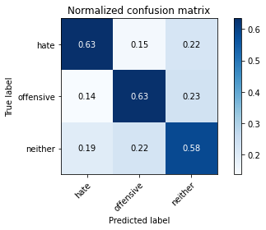

precision recall f1-score support

hate 0.15 0.63 0.24 41

offensive 0.27 0.63 0.38 95

neither 0.93 0.58 0.72 714

accuracy 0.59 850

macro avg 0.45 0.62 0.44 850

weighted avg 0.82 0.59 0.66 850

average eval_loss: 0.8957339074722556, accuracy: 0.591764705882353

training 9 epoch...

3.742884635925293 seconds used......

9 training finished! average train loss: 0.2572608265806647

total clf loss: 4.350188620388508 total adv loss: 0.011622685924521647

evaluating...

Confusion matrix, without normalization

[[ 30 5 6]

[ 18 59 18]

[175 160 379]]

Normalized confusion matrix

[[0.73170732 0.12195122 0.14634146]

[0.18947368 0.62105263 0.18947368]

[0.24509804 0.22408964 0.53081232]]

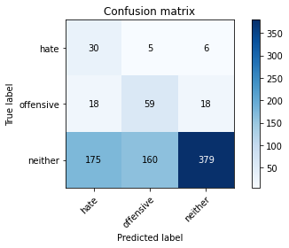

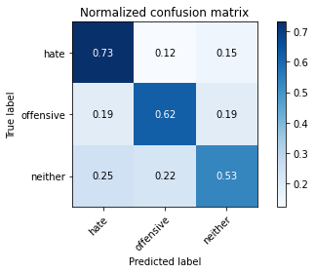

precision recall f1-score support

hate 0.13 0.73 0.23 41

offensive 0.26 0.62 0.37 95

neither 0.94 0.53 0.68 714

accuracy 0.55 850

macro avg 0.45 0.63 0.43 850

weighted avg 0.83 0.55 0.62 850

average eval_loss: 0.9921935179898905, accuracy: 0.5505882352941176

training 10 epoch...

3.7253026962280273 seconds used......

10 training finished! average train loss: 0.17990274332902012

total clf loss: 3.049434408545494 total adv loss: 0.004456128808669746

evaluating...

Confusion matrix, without normalization

[[ 32 4 5]

[ 33 51 11]

[297 127 290]]

Normalized confusion matrix

[[0.7804878 0.09756098 0.12195122]

[0.34736842 0.53684211 0.11578947]

[0.41596639 0.17787115 0.40616246]]

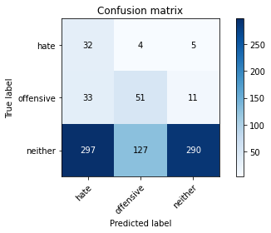

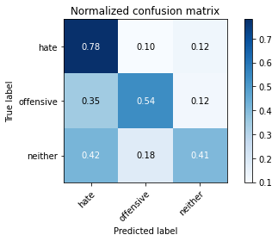

precision recall f1-score support

hate 0.09 0.78 0.16 41

offensive 0.28 0.54 0.37 95

neither 0.95 0.41 0.57 714

accuracy 0.44 850

macro avg 0.44 0.57 0.37 850

weighted avg 0.83 0.44 0.53 850

average eval_loss: 1.2599073149437128, accuracy: 0.4388235294117647

5 run......

training 1 epoch...

3.7645397186279297 seconds used......

1 training finished! average train loss: 2.5823034959680893

total clf loss: 21.132304191589355 total adv loss: 11.383427768945694

evaluating...

Confusion matrix, without normalization

[[ 15 22 4]

[ 16 66 13]

[302 172 240]]

Normalized confusion matrix

[[0.36585366 0.53658537 0.09756098]

[0.16842105 0.69473684 0.13684211]

[0.42296919 0.24089636 0.33613445]]

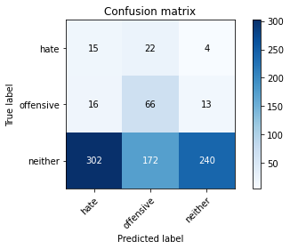

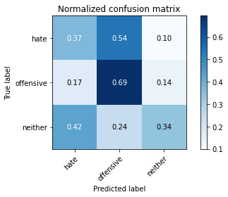

precision recall f1-score support

hate 0.05 0.37 0.08 41

offensive 0.25 0.69 0.37 95

neither 0.93 0.34 0.49 714

accuracy 0.38 850

macro avg 0.41 0.47 0.32 850

weighted avg 0.81 0.38 0.46 850

average eval_loss: 1.124732523463493, accuracy: 0.3776470588235294

training 2 epoch...

3.749842405319214 seconds used......

2 training finished! average train loss: 2.3142146082485424

total clf loss: 18.597970008850098 total adv loss: 10.371839225292206

evaluating...

Confusion matrix, without normalization

[[ 14 24 3]

[ 6 64 25]

[170 204 340]]

Normalized confusion matrix

[[0.34146341 0.58536585 0.07317073]

[0.06315789 0.67368421 0.26315789]

[0.23809524 0.28571429 0.47619048]]

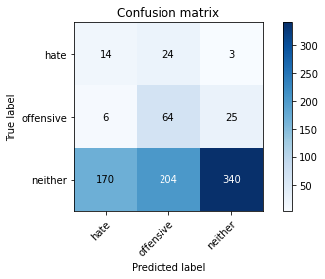

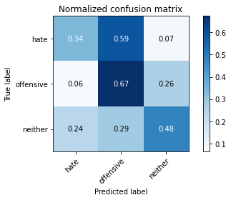

precision recall f1-score support

hate 0.07 0.34 0.12 41

offensive 0.22 0.67 0.33 95

neither 0.92 0.48 0.63 714

accuracy 0.49 850

macro avg 0.41 0.50 0.36 850

weighted avg 0.80 0.49 0.57 850

average eval_loss: 1.0558416288952495, accuracy: 0.49176470588235294

training 3 epoch...

3.726459264755249 seconds used......

3 training finished! average train loss: 2.1777626626631794

total clf loss: 17.48683661222458 total adv loss: 9.767564505338669

evaluating...

Confusion matrix, without normalization

[[ 29 11 1]

[ 20 68 7]

[340 150 224]]

Normalized confusion matrix

[[0.70731707 0.26829268 0.02439024]

[0.21052632 0.71578947 0.07368421]

[0.47619048 0.21008403 0.31372549]]

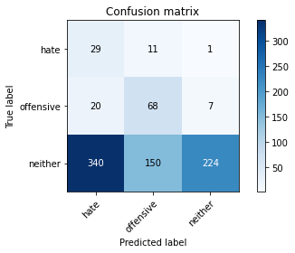

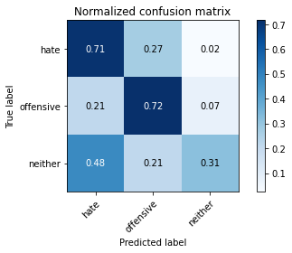

precision recall f1-score support

hate 0.07 0.71 0.13 41

offensive 0.30 0.72 0.42 95

neither 0.97 0.31 0.47 714

accuracy 0.38 850

macro avg 0.45 0.58 0.34 850

weighted avg 0.85 0.38 0.45 850

average eval_loss: 1.0867482229720715, accuracy: 0.3776470588235294

training 4 epoch...

3.733266830444336 seconds used......

4 training finished! average train loss: 1.79357971163357

total clf loss: 15.669236779212952 total adv loss: 7.410809129476547

evaluating...

Confusion matrix, without normalization

[[ 33 7 1]

[ 39 50 6]

[384 125 205]]

Normalized confusion matrix

[[0.80487805 0.17073171 0.02439024]

[0.41052632 0.52631579 0.06315789]

[0.53781513 0.17507003 0.28711485]]

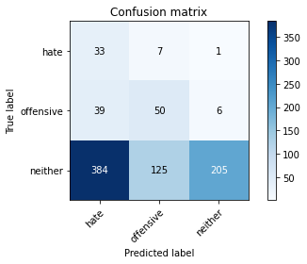

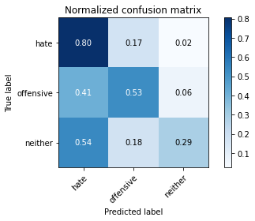

precision recall f1-score support

hate 0.07 0.80 0.13 41

offensive 0.27 0.53 0.36 95

neither 0.97 0.29 0.44 714

accuracy 0.34 850

macro avg 0.44 0.54 0.31 850

weighted avg 0.85 0.34 0.42 850

average eval_loss: 1.1124865897866183, accuracy: 0.3388235294117647

training 5 epoch...

3.771548271179199 seconds used......

5 training finished! average train loss: 1.426583633703344

total clf loss: 13.25777941942215 total adv loss: 5.497071020305157

evaluating...

Confusion matrix, without normalization

[[ 27 12 2]

[ 15 68 12]

[236 151 327]]

Normalized confusion matrix

[[0.65853659 0.29268293 0.04878049]

[0.15789474 0.71578947 0.12631579]

[0.33053221 0.21148459 0.45798319]]

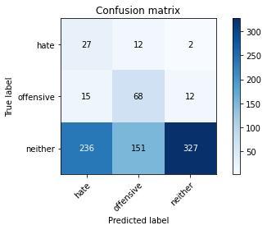

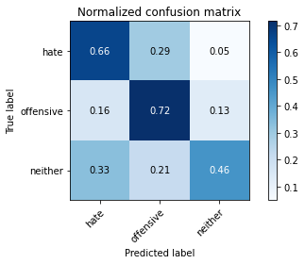

precision recall f1-score support

hate 0.10 0.66 0.17 41

offensive 0.29 0.72 0.42 95

neither 0.96 0.46 0.62 714

accuracy 0.50 850

macro avg 0.45 0.61 0.40 850

weighted avg 0.84 0.50 0.58 850

average eval_loss: 0.9744839273219885, accuracy: 0.4964705882352941

training 6 epoch...

3.746126651763916 seconds used......

6 training finished! average train loss: 0.8045633452780107

total clf loss: 10.244832187891006 total adv loss: 1.7163723744452

evaluating...

Confusion matrix, without normalization

[[ 32 6 3]

[ 27 51 17]

[286 95 333]]

Normalized confusion matrix

[[0.7804878 0.14634146 0.07317073]

[0.28421053 0.53684211 0.17894737]

[0.40056022 0.13305322 0.46638655]]

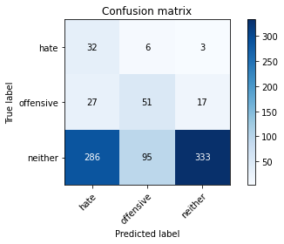

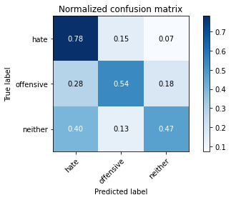

precision recall f1-score support

hate 0.09 0.78 0.17 41

offensive 0.34 0.54 0.41 95

neither 0.94 0.47 0.62 714

accuracy 0.49 850

macro avg 0.46 0.59 0.40 850

weighted avg 0.83 0.49 0.58 850

average eval_loss: 0.9851147816624752, accuracy: 0.4894117647058824

training 7 epoch...

3.735133647918701 seconds used......

7 training finished! average train loss: 0.4260235376217786

total clf loss: 7.011038273572922 total adv loss: 0.11568095337133855

evaluating...

Confusion matrix, without normalization

[[ 28 10 3]

[ 21 60 14]

[240 181 293]]

Normalized confusion matrix

[[0.68292683 0.24390244 0.07317073]

[0.22105263 0.63157895 0.14736842]

[0.33613445 0.2535014 0.41036415]]

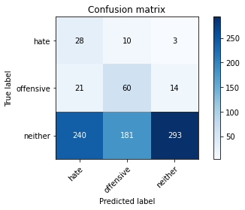

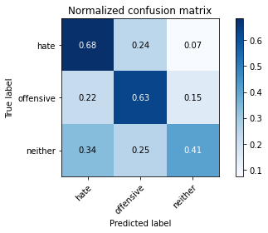

precision recall f1-score support

hate 0.10 0.68 0.17 41

offensive 0.24 0.63 0.35 95

neither 0.95 0.41 0.57 714

accuracy 0.45 850

macro avg 0.43 0.57 0.36 850

weighted avg 0.83 0.45 0.53 850

average eval_loss: 1.082683673431707, accuracy: 0.44823529411764707

training 8 epoch...

3.7677361965179443 seconds used......

8 training finished! average train loss: 0.33448216932661395

total clf loss: 5.587522216141224 total adv loss: 0.04933734102814924

evaluating...

Confusion matrix, without normalization

[[ 29 10 2]

[ 19 69 7]

[244 222 248]]

Normalized confusion matrix

[[0.70731707 0.24390244 0.04878049]

[0.2 0.72631579 0.07368421]

[0.34173669 0.31092437 0.34733894]]

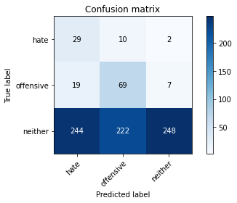

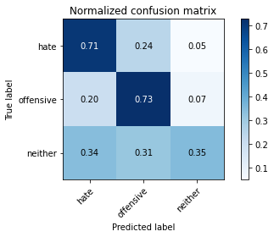

precision recall f1-score support

hate 0.10 0.71 0.17 41

offensive 0.23 0.73 0.35 95

neither 0.96 0.35 0.51 714

accuracy 0.41 850

macro avg 0.43 0.59 0.34 850

weighted avg 0.84 0.41 0.48 850

average eval_loss: 1.2929560847060626, accuracy: 0.40705882352941175

training 9 epoch...

3.7829020023345947 seconds used......

9 training finished! average train loss: 0.2155976339298136

total clf loss: 3.623293861746788 total adv loss: 0.02093296285966062

evaluating...

Confusion matrix, without normalization

[[ 25 9 7]

[ 18 45 32]

[190 130 394]]

Normalized confusion matrix

[[0.6097561 0.2195122 0.17073171]

[0.18947368 0.47368421 0.33684211]

[0.26610644 0.18207283 0.55182073]]

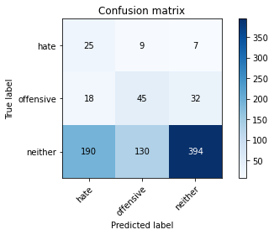

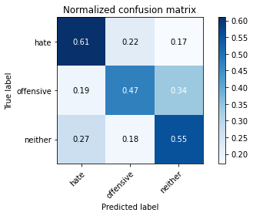

precision recall f1-score support

hate 0.11 0.61 0.18 41

offensive 0.24 0.47 0.32 95

neither 0.91 0.55 0.69 714

accuracy 0.55 850

macro avg 0.42 0.55 0.40 850

weighted avg 0.80 0.55 0.62 850

average eval_loss: 0.9838971208001293, accuracy: 0.5458823529411765

training 10 epoch...

3.732999086380005 seconds used......

10 training finished! average train loss: 0.1541762632482192

total clf loss: 2.570433057844639 total adv loss: 0.02528170163714094

evaluating...

Confusion matrix, without normalization

[[ 27 5 9]

[ 27 42 26]

[220 116 378]]

Normalized confusion matrix

[[0.65853659 0.12195122 0.2195122 ]

[0.28421053 0.44210526 0.27368421]

[0.30812325 0.16246499 0.52941176]]

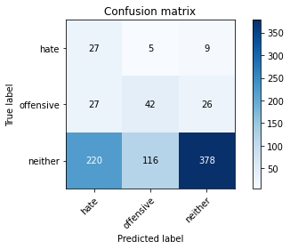

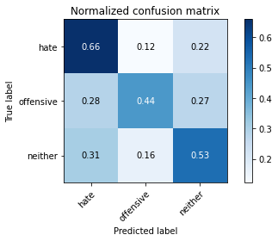

precision recall f1-score support

hate 0.10 0.66 0.17 41

offensive 0.26 0.44 0.33 95

neither 0.92 0.53 0.67 714

accuracy 0.53 850

macro avg 0.42 0.54 0.39 850

weighted avg 0.80 0.53 0.61 850

average eval_loss: 1.0779700473297473, accuracy: 0.5258823529411765